**DATA ANALYST – PROJECT 1 SUMMARY**

1. Step to prepare the data

First, I do the query: SELECT * FROM global_data

This will get the data temperatures of global

Second, I do SELECT * FROM city_data WHERE city='Hanoi'

to get the temperatures of Hanoi. I’m living in Ha Noi, Viet Nam.

* I’m choosing Excel to be visualized data in the chart.
* I’m using the AVERAGE function in excel to calculate the average of temperatures.
* I consider that Should I calculate all the years or not? And besides that, using a line chart or bar chart, because I saw that also good. Finally, I decision choose line chart.

1. Line chart with local and global temperature trends

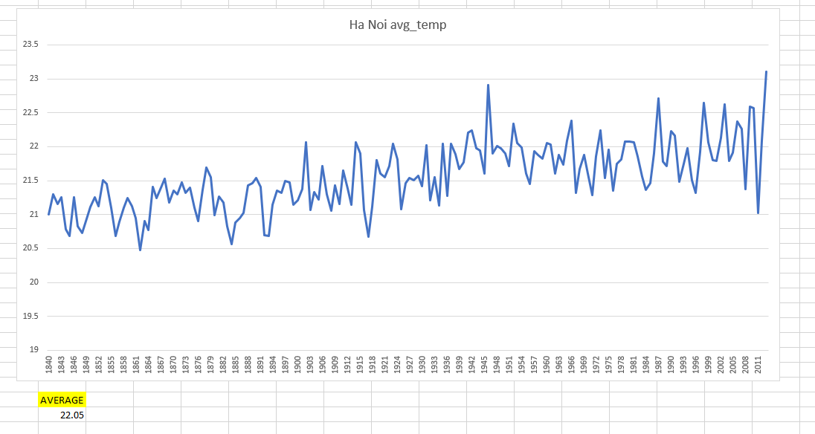

Figure 1: Local Line Chart

This line chart corresponds with the years from 1840 to 2013.

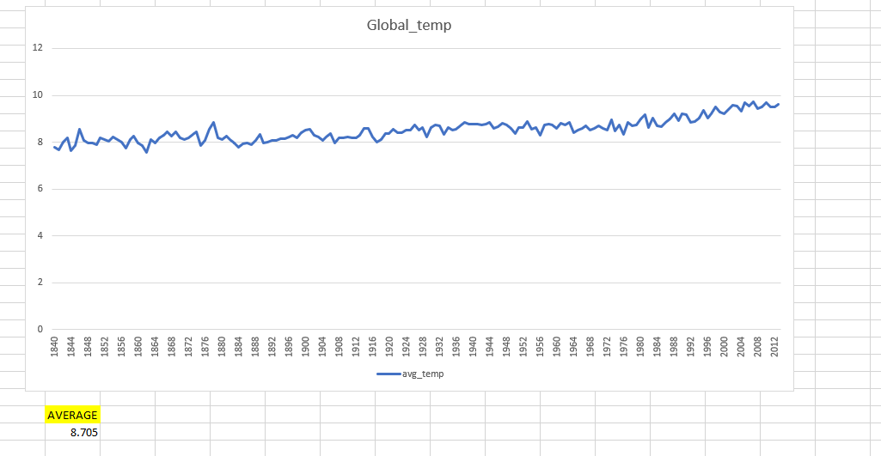

Figure 2: Global line chart

The data of global from 1750 to 2015. But to easily compare, I draw a line chart for global temperature from 1840 to 2013.

1. Observations.

* Firstly, I see the volatility in my local more than global temperatures.
* Secondly, I saw that the temperature has trended up.
* Thirdly, The gap between the highest and lowest in the local is quite big (> 3 degrees C), while the global one is insignificant (~2 degrees C)
* Finally, The alteration in the local is unstable, while the global is in the opposite.